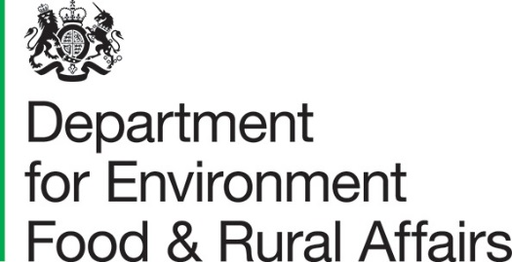

Wildlife Rich Habitat Fund Guidance

For FiPL/PL teams
Date: April 2026
Version: 1

Delivering the Wildlife‑Rich Habitat Funding
Guidance for FiPL Officers and PL teams

1. Introduction

1.1 Purpose of this Guidance
This document provides operational guidance for FiPL/PL officers delivering the Wildlife‑Rich Habitat Fund (WRHF), a ring‑fenced funding allocation designed to accelerate the creation of wildlife-rich habitat within protected landscapes (PLs). It explains how this funding differs from FiPL funding and how it interacts with other schemes.
To reiterate, this document details how this fund will differ from FiPL – if you cannot find guidance that you are looking for, then it’s likely standard FiPL rules apply, and you should refer to the FiPL guidance.

1.2 Background
The WRHF supports national commitments including:
- The Environment Act habitat target: To create or restore at least 500,000 hectares of a range of wildlife-rich habitats outside of protected sites by 2042, with an interim target of a total of 250,000 hectares by 2030.
- The 30by30 target: To effectively conserve and manage 30% of England’s land by 2030.
- The Protected Landscapes Targets and Outcomes Framework: Restore or create more than 250,000 hectares of a range of wildlife-rich habitats within Protected Landscapes, outside protected sites by 2042.

The WRHF will support delivery of the Environmental Improvement Plan and Local Nature Recovery Strategies (LNRS).

1.3 How this fund differs from FiPL
Fund feature | Standard FiPL | WRHF
Funding origin   | Farming Directorate. | National Biodiversity Division.
Focus   | Supports nature, climate, people and place outcomes. | Ringfenced for wildlife-rich habitat creation outside of protected sites. See below for definitions of wildlife-rich habitat
Beneficiaries   | Important that funding directly benefits or involves farmers. | Does not need to directly benefit or involve farmers. PLs or eNGOs can use funding without farmer involvement.
Relationship with agri-environment schemes   | Projects must add value to agri-environment schemes and cannot replicate funding like-for-like. | Ideally projects should add value, but it may be appropriate for some projects to replicate agri-environment activities.
Payment schedule   | For capital, payment on completion of works. | Staged payments accepted on completion of discrete project activities, for example:  - Payment 1, after completion of baseline ecological surveys.  - Payment 2, after completion of fencing.  - Payment 3, after completion of wetland creation works.
Assessment   | Projects over £10,000 are assessed by Local Assessment Panels. | All projects are assessed by senior leaders in your PL organisation. It is the responsibility of the PL to assign this person(s).
Maximum Project Amount   | Maximum suggested grant size is £250,000 (some PLs have set a lower threshold). | No maximum grant size.
Protected Sites | No restriction of funding WRH activity on protected sites (SSSIs SACs, SPAs and MCZs.) | Funding must only be applied to areas outside protected sites.
Aside from the above deviations, guidance set out in the National Framework will apply alongside the FiPL documentation e.g. application form and onward agreement.
1.4 How this funding works alongside other funding streams
As per the FiPL process, consideration must be given to the most appropriate source of funding for the applicant/area. There are several farming schemes and programmes that will fund actions for habitat restoration and creation for farmers and land managers to choose from. You must encourage farmers and landowners to consider which grant scheme will be most suited to them and their specific circumstances. When funding through WRHF, ideally projects should add value although it may be appropriate for some projects to replicate agri-environment activities.
Land managers will still be eligible for Countryside Stewardship (CS), however there is no guarantee that they can enter any scheme following completion of the work. Work funded through WRHF must be completed before eligibility for any maintenance payments if they are accepted into CS. This is the same as for FiPL.
1.5 Land purchase
The WRHF is not intended to fund land acquisitions. The PL core capital funding can support land purchase. If you’ve suggested using WRHF for land purchase, we recommend considering core capital funding. Following purchase, WRH funding can be used to pay for the necessary actions to establish WRH.
See Q&A at the end of this document for frequently asked questions.

What Counts as Wildlife‑Rich Habitat Creation

Definition
Wildlife‑rich habitat creation refers to establishing new habitat of a type listed in TIN219. Wildlife‑rich habitat must be a priority habitat or a Schedule 1 habitat that is of “sufficient quality” which means it is capable of supporting the typical flora and fauna associated with that habitat type.
For FiPL purposes, WRHF must:
- Increase the extent of wildlife‑rich habitat (not improve or maintain condition).
- Deliver actions that are sufficient for the relevant habitat type to develop.
- Follow the definitions and desired outcomes in Table 2 of TIN219
Once the sufficient actions are underway so there is confidence that the wildlife-rich habitat will be established, the works can count towards the habitat target. This recognises that recovery as a response can be ongoing.

Routes that qualify as Wildlife‑Rich Habitat Creation
- Creation on land where wildlife-rich habitat is absent.
Creation applies where actions establish a wildlife‑rich habitat on land that is currently not a wildlife-rich habitat type.
- Creation via restoration of degraded habitat (“restoration‑as‑creation”)
Only the below types of habitat can be considered degraded habitats and therefore qualify for restoration. These are habitats that no longer support the typical flora and fauna expected for that habitat type due to pressures such as altered hydrology, pollution, nutrient loading, invasive non-native species, or inappropriate vegetation structure. Eligible degraded habitats include:
- Any existing habitat on drained peat where hydrological restoration is required to restore peatland wildlife-rich habitat.
- Coastal floodplain grazing marsh even when not on peat, where it is being restored to a wetland habitat.
- Freshwater, coastal and estuarine habitats affected by pollution, hydrological modification, physical damage, or INNS where sufficient action is taken to address these pressures
- Woodlands with less than 70% native canopy, where canopy reduction of non-native species is required to establish a woodland with at least 70% native canopy (including PAWS restoration)
- Terrestrial semi-natural habitats behind sea defences where actions restore coastal processes such as saline inundation or managed realignment.
- Habitat listed in Schedule 1 that Biodiversity Net Gain has assessed as “medium distinctiveness” and not in good condition, where the project will restore it to a priority habitat.

Eligible Habitat Types
FiPL can fund the creation of only those habitat types listed in Table 2 of TIN219. These include Priority Habitats and Schedule 1 habitats that should be expected to reach sufficient quality. Officers must check habitat definitions and desired outcomes directly against Table 2 in TIN219.

PL are asked to prioritise projects that will deliver wildlife-rich habitat types that have been historically under delivered. The 2025 evidence report shows that heathland, ponds, and traditional orchards have been the least delivered so far. It is also important to note that the contribution of arable field margins (AFM) to the habitat target is capped at 40,000 hectares, because they are relatively easy to deliver, and the legislation calls for a diverse range of habitats. We have likely already reached this cap, so projects should focus on delivering other habitat types instead.

Eligible and ineligible activities

An action is the set of interventions needed to create or restore wildlife-rich habitat and must be sufficient, when taken together, to establish the habitat. Partial steps do not constitute an action.
The following do not count towards the habitat target and so should not be funded by the WRHF:
- Partial or insufficient actions.
- Maintenance or enhancement of existing wildlife‑rich habitat.
- Compensatory habitat required by planning.
- Actions on protected sites designated as of January 2023. Action can take place on land that has been or may be designated after January 2023.
- Creation that destroys an existing wildlife‑rich habitat (e.g., creating dry habitats on peat).

Quick Assessment Checklist
See Figure 1 for a flow chart to support decision making on whether projects are eligible for the WRHF.
This can be used by FiPL officers to assess whether an activity is eligible for funding or not.

FiPL Officers should confirm and document that:
- The proposal creates new wildlife-rich habitat (not maintenance)
- The habitat type appears in TIN219 Table 2
- Site conditions and proposed actions match the habitat’s desired outcome in TIN219
- Actions are evidence based and sufficient to establish habitat
- The land is outside of protected sites
- The habitat creation action aligns with priorities identified in the LNRS and the PL management plan
- Funding is compatible with other schemes (no double funding)

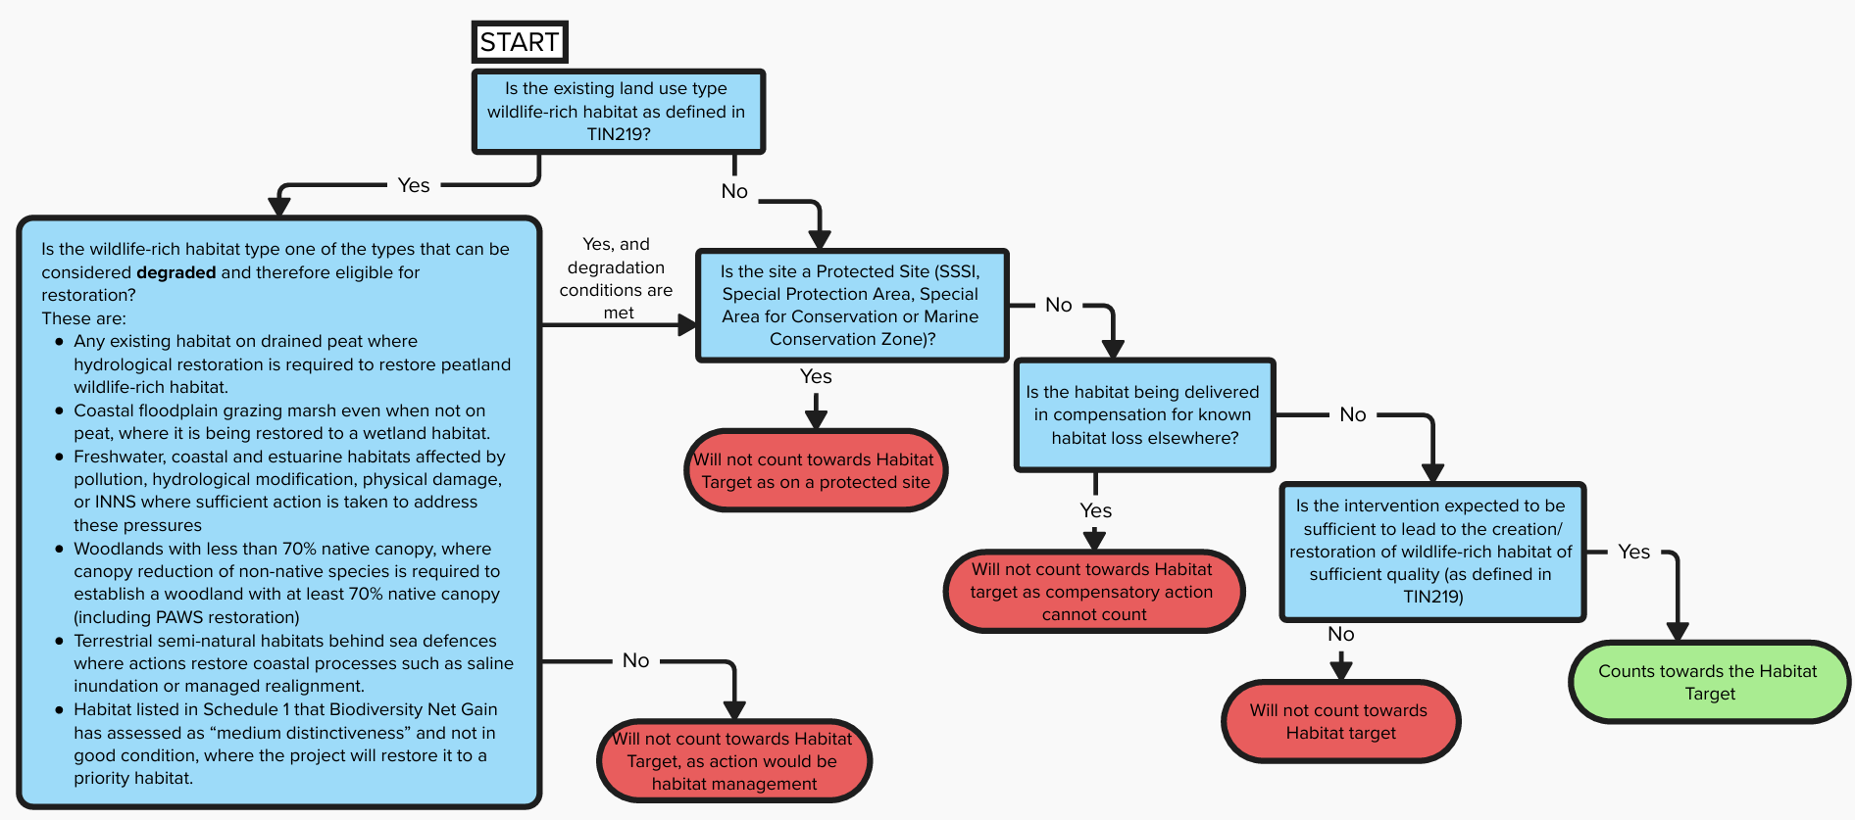
Figure 1 Flow chart to support decision making on whether a project will count towards the habitat target

Worked Examples
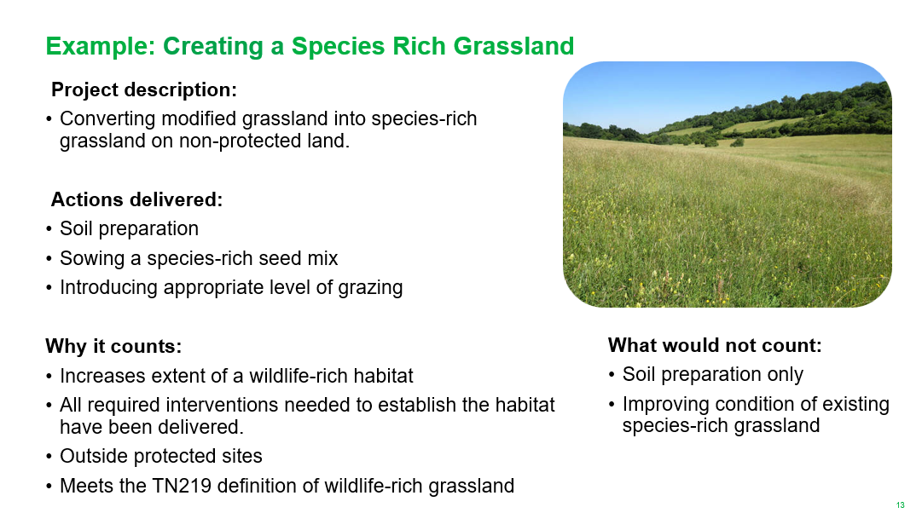
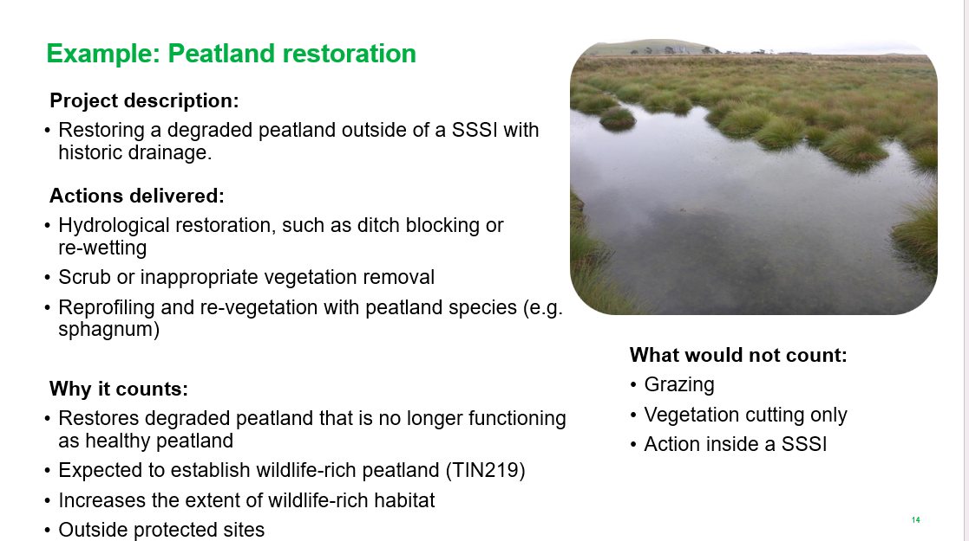
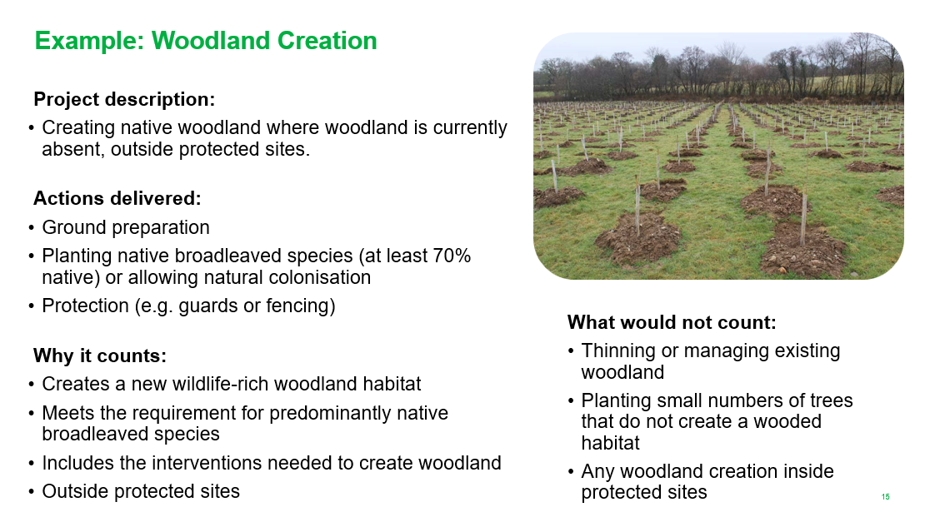

Q&A
Q – Do the same payment rates apply as FiPL?
A – Yes, alignment with other schemes e.g. that payment rates for capital works should, by default, be aligned with those set out in Defra schemes, including the Farming in Protected Landscapes programme – for transparency, accountability and consistency. There may be exceptional circumstances where a higher or lower rate is justified due to the specialised and/or bespoke nature of the project. However, any deviation will be the responsibility of the delivery partner to justify. Justification must be based on robust evidence against the exceptional circumstances and demonstrate value for money. Payment rates may be subject to spot checks as part of routine grant management.
Q - Can I capitalise x, y, and z?
A – Guidance on what can be capitalised is set out in the National Framework and supporting documents. PL teams are responsible for making these classifications and keeping adequate records to show that labour costs charged to capital are correct.
Q - Can advice, baseline surveys and management plans be capitalised if delivered within the one-year timescale?

A – See above, and note that work that directly delivers the habitat actions required to create a wildlife-rich habitat should be prioritised over work on advice and surveys.

Q - After what length of time and how do we have to demonstrate that habitat has reached the wildlife-rich criteria?
A - There is no need to demonstrate that the habitat has reached ‘sufficient quality’ as defined by TIN219, although you should have confidence that the actions will be sufficient for this. The target is an action-based target, so delivery partners only need to have reasonable confidence that they are undertaking all of the actions required that could be reasonably expected to lead to the establishment of wildlife-rich habitat.
Q - Can fencing costs be included?
A - Yes. If fencing is a key action required to ensure the habitat establishes successfully, it can be included as an eligible cost.
Q -Will we be able to deliver schemes off-shore (technically beyond the boundary of the NL)? Especially in sub-tidal areas.
A –Yes. Similar to FiPL, as long as the scheme is clearly supporting and benefiting the PL. Sub-tidal/offshore areas are also eligible where they are part of the PL's management plan.
Q - Will project activities be able to be separated to WRH budget individually or will it be needed to be whole project based?
A - Yes, it is fine to separate WRH budget to fund individual actions — for example, part of a project funded by standard FiPL and part funded by WRH. However, the ambition is for larger-scale, focused, whole-project approaches as this is where the best outcomes are achieved. Where a project is only a piecemeal addition, it should also be questioned whether it should simply be funded through standard FiPL.
Q - Please clarify what works to streams and rivers are eligible for the Habitats Fund?
A - Works can count to restore rivers and streams as they are a type of wildlife-rich habitat that can be restored by addressing pressures. The key requirement is that all pressures must be addressed for it to count: biology, morphology, hydrology and water quality, not just one element. With freshwater habitats this can be complicated, especially where upstream pressures are outside the control of the land in question, so a catchment-scale approach and working with partners is important. If there is confidence that pressures are being addressed elsewhere as part of a wider programme, that work can still count.
Q- Why should we avoid prioritising projects that deliver arable field margins (AFM)?
A: Because the contribution of arable field margins to the habitat target is capped at 40,000 hectares. AFM are relatively easy to deliver, and the legislation requires a diverse range of habitats. We have likely already reached this cap, so projects should focus on delivering other habitat types instead.

