A baseline Greenhouse Gas (GHG) footprint assessment has been carried out by Small World Consulting for all National Parks and some AONBs using a consistent methodology.
It assesses GHG emissions relating to the consumption of all goods and services by local residents, businesses and visitors, in addition to land-based emissions. It therefore differs from production-based carbon footprint assessments which only look at the emissions directly produced within the National Park, plus those arising from production of the electricity used.
By taking the consumption-based approach, this report also assesses indirect GHG emissions embedded in the supply chain of goods and services consumed, which better reflects the full climate impact of people’s lifestyles. The most important of these are the impacts of food, of other purchased items (such as cars, clothes, IT equipment, household goods and furnishings), and of residents’ and visitors’ travel to and from the National Park.
The headline annual emission figures for the Exmoor National Park are:
- Emissions from residents - 149,381 tCO₂e (42.8 kgCO₂e per resident per day; 15.6 tCO₂e per resident per year; the UK average is 12.4 tCO₂e per person per year)
- Emissions from visitors while in the National Park – 42,416 tCO₂e (18.3 kgCO₂e per visitor per day)
- Emissions from visitors travelling to/from the National Park – 82,630 tCO₂e (56.5 kgCO₂e per visit)
- Industry emissions – 66,056 tCO₂e
- Land use emissions (non-CO2, including livestock and fertiliser) 119,889 tCO₂e

Residents: 149,381 tCO₂e
Visitors travel to & from the National Park: 82,630 tCO₂e
Figure 1: (left) Residents’ GHG emissions in Exmoor National Park by percentage
Figure 2: (top right) Visitors’ GHG emissions on the way to & from Exmoor National Park by percentage
Figure 3: (bottom right) Visitors’ GHG emissions while in Exmoor National Park

Figure 4: The Exmoor National Park consumption-based GHG emissions for Industry by percentage
Further analysis highlights particular factors relevant to Exmoor:
- The per capita footprint of Exmoor's residents is estimated to be around 26% higher than the UK average due to a number of factors including a high level of retired people and consequent higher levels of spending on health; greater levels of flying and driving; and higher household fuel consumption for heating and electricity
- Exmoor has around 1.5 million visitors annually. Visitors’ footprint while in the National Park is dominated by food (48%), followed by driving (14%) and accommodation (12%)
- The visitors’ footprint while travelling to and from the National Park is dominated by driving (62%), followed by flying (18%). Overall, the visitors’ footprint while travelling to and from the National Park is more than twice the emissions attributed to their activities while in the National Park, in part as a result of the relative remoteness of Exmoor.
- The industry footprint in the Exmoor National Park is dominated by agriculture, forestry and fishing (63%), followed by accommodation and food services (8%) and production (all types of manufacturing and energy generation; 7%).
- The land use sector contains both carbon sources (e.g. emissions from livestock, synthetic fertiliser use, degrading peat soils) and carbon sinks (including carbon sequestration in soils and biomass through woodland creation, peatland restoration and regenerative agriculture practices)

To indicate the scale of annual GHG emissions from Exmoor’s residents and visitors, you would need to plant around 740 Premier League football pitches with broadleaf trees, and let them grow for over 100 years, to mitigate the combined GHG emissions of residents and visitors for the single year of 2019. This shows the need to prioritise GHG emissions reductions to limit global warming, rather than just mitigating emissions through carbon removal.

Target areas for action
The recommendations in the report focus on six categories of GHG emissions considered to be most relevant for action at the National Park level. This excludes some aspects of the overall carbon footprint such as resident’s travel outside the National Park and use of health and education services (apart from the buildings’ energy use, which is included), as these are considered outside the scope of influence or will be dealt with by national policy and action.
The target categories are:
- Energy consumption by residents, visitors and industry (driving, central heating, electricity use, and other forms of direct energy consumption), including emissions in fuel supply chains
- Food and drink consumed by residents and visitors
- Other goods purchased by residents and visitors (e.g. clothing, electronic equipment, furniture, soft furnishings, and cars)
- Visitor travel to and from the National Park (excluding flights; including embedded footprint of cars)
- Land use non-CO₂ component (including emissions from livestock and fertilisers)
- Land use CO₂ component (including both emissions from degrading mineral soils and peatlands and sequestration by woodlands, individual trees, hedges, mineral soils and healthy peatlands)

Across these six categories, the 2019 GHG baseline for the Exmoor National Park is estimated at 361,063 tCO₂e per year.

Figure 5. 2019 GHG emissions baseline for Exmoor National Park represented using six broad categories of emissions
Most of these emissions are not directly within the management responsibilities of the National Park Authorities but are where efforts should be focused for partnership work with local authorities and a wide range of stakeholders to meet the net-zero targets.

Net Zero Pathway for Exmoor National Park
The report provides a recommended pathway to Net-Zero in line with the international commitments made in the Paris Agreement to limit global temperature rises to 1.5 degrees, and the UK’s targets for specific sectors.
The net-zero pathway is derived from science-based assessments, including: the UK’s Sixth Carbon Budget; Tyndall Carbon Budget Tool; UK’s National Food Strategy; and UNFCCC Paris Agreement. The proposed emissions reduction and carbon sequestration targets require immediate, ambitious action to be taken across all six emission categories.
In order to meet these ambitious, science-based commitments, the following emissions reduction targets have been identified for Exmoor National Park to 2050:
- Sustainable energy – 12.8% pa (per annum) cut in emissions arising from energy usage by residents, visitors and industry
- Sustainable food & drink – 5% pa cut in emissions arising from consumption of food and drink
- Sustainable purchasing – 5% pa reduction in emissions from other goods purchased by residents and visitors
- Sustainable travel – 10% pa reduction in emissions from visitor travel to and from the National Park
- Sustainable agriculture – 5% pa cut in emissions from livestock and fertilisers
- Sustainable land use – a net reduction of 9,436 tCO₂e emissions pa from restoring degraded peatlands and mineral soils, and increasing sequestration of carbon in healthy soils, woodlands, and other vegetation:
  - Woodland creation (130 ha pa created)
  - Peatland restoration (771 ha pa restored)
  - Agroforestry (76 ha pa rolled out)
  - New hedgerows (4 ha pa created)
  - Adding legumes to improved grassland (555ha pa rolled out)
  - Cover cropping (38 ha pa rolled out)

When converted to changes in the net GHG emissions, emissions reduction due to peatland restoration (roughly minus 5,500 tCO₂e per year) provides nearly 3 times more effect compared to the second-largest contribution from carbon sequestration through new native broadleaf/mixed woodland, and nearly 5 times more effect compared to the third-largest contribution from carbon sequestration through adding legume species (applicable to improved grassland only). This clearly illustrates the priorities for land use measures in the Exmoor National Park in order to achieve net zero emissions.

Figure 6. Percentage breakdown of the projected cumulative reduction in net annual GHG emissions for Exmoor National Park between the base year (2019) and 2050 according to the individual emitting categories and carbon sequestration measures considered in this assessment
If the report’s recommendations are followed, and using 2019 as the baseline year, Exmoor National Park is projected to reach net zero GHG emissions by 2035. However, the high levels of ambition for the different sectors required to achieve the required cuts in emissions are likely to take several years to achieve, particularly as decarbonisation trends to date have been relatively small in magnitude compared to what is required. These factors are expected to push the projected net zero year back until the early 2040s, which is illustrated in the figure below. Nevertheless, the trajectories for each of the six components of the target are still expected to become steep and challenging in the coming years, reflecting the severity of the climate emergency. We note that the net zero date also depends on the unique circumstances for each landscape, and should therefore not be taken in isolation as a level of ambition.

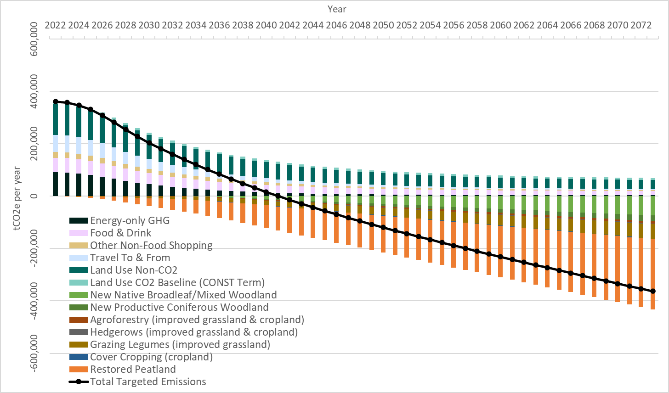
Figure 7. Exmoor National Park: Alternative pathway to Net Zero using 2022 as the base year (based on the 2019 data) and assuming 5-year lags in ratcheting up the efforts to the recommended levels

